**PROJECT JOURNAL**

A Journal for Max MSP

by Julia Broden

This journal is about short resumes on the daily work of my project: A riddle programmed on the basis of how a neuron works, with sample and video feedback.

**Phase 1: Searching for inspiration**

*Tuesday, 23rd April*

Since I´m a big fan of moog synthesizers, their aesthetic and warm sounds, I want to start my research for possible directions of my project in Max in this area. After some research on the cycling74.com website and YouTube I decided to focus on subtractive synthesis. I did some revision of the lectures and workshops which covered synthesis. Additionally, I found many MSP tutorials about it.

I found an inspiring demo of a patch which was based on the Moog Sub Phatty.

* <https://www.youtube.com/watch?v=E1QUCU51eng>

My big question at the end of the day:

Considering these inspirational inputs, how could my project look like?

*Wednesday, 24th April*

I didn´t felt ready yet to start working on my one patch. Since I still had no concrete idea or concept, I decided to expand my field of research.

I found on the YouTube channel from Ableton a recent presentation about Max 8’s new multi-channel audio programming system.

* <https://www.youtube.com/watch?v=Y4YLy7kqcr8&t=1317s>

Next, I came across a tutorial about neural networks programmed in Max/MSP. And here it clicked. I feel excited about the overlap between brain function and how computers think.

* <https://www.youtube.com/watch?v=yGWMSkaCoS0&t=1516s>

I threw my moog idea overboard and decided to go for a neuron as the basis of my project. What could I do with it? How to combine it with musical aspects?

Beside these resources, I also took inspiration from Daphne Oram, as a female pioneer of electronic music and the documentary “The Creative Brain” by David Eagleman. It´s about creativity, with the take home message, that true creativity takes the familiar and combines it in a way, how it was never combined before and thus creates something new and original.

**Phase 2: Forming a concept**

*Thursday, 25th April*

While reconstructing the neuron in Max with the help of the tutorial, I figured that the output of each row of the matrix would be the best place to start off merging it together with some other constructions.

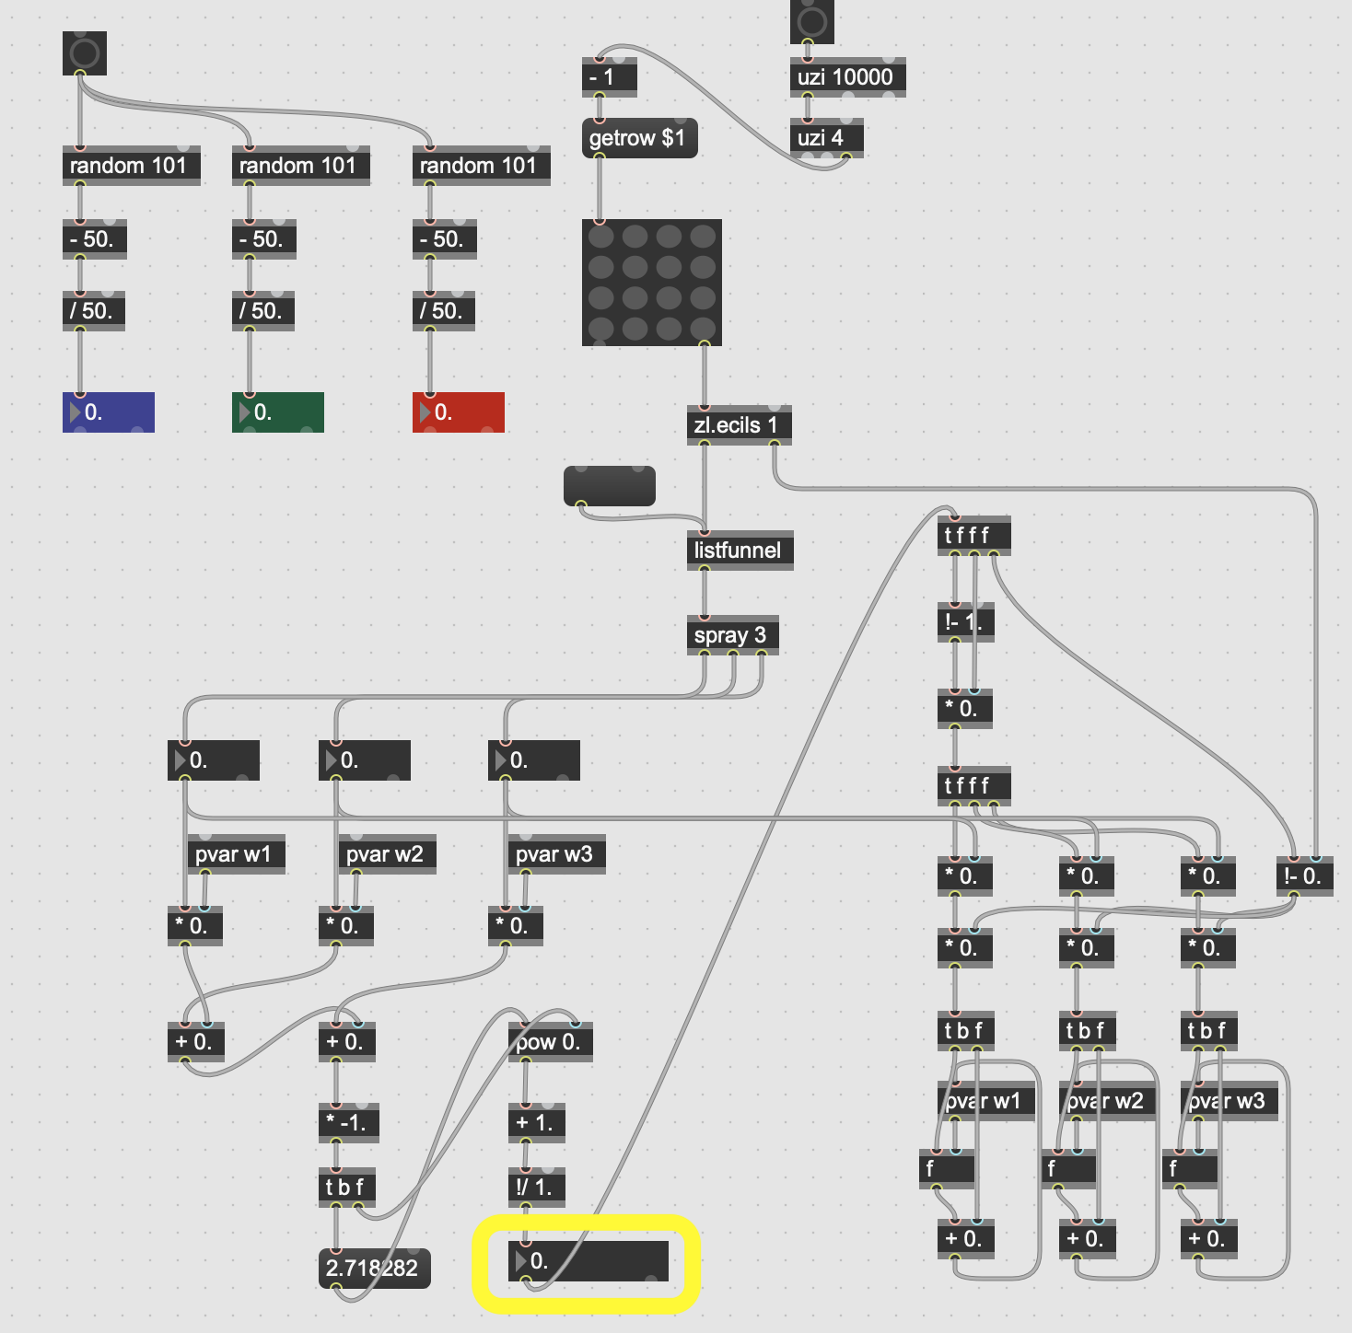

*The neuron: Top left the random weights. The matrix with three inlet columns and one output. Bottom right the weight adjustment function. The output is circled in yellow.*

Since the output is always a number between 0 and 1, I want to try and use that for a change in the playback speed of samples.

The patch from the tutorial was based on an article about neural networks in python code.

* <https://medium.com/technology-invention-and-more/how-to-build-a-simple-neural-network-in-9-lines-of-python-code-cc8f23647ca1>

The table in this article, explaining how the neuron will learn from data, made me start thinking about my project as some sort of a riddle the user can try to solve.

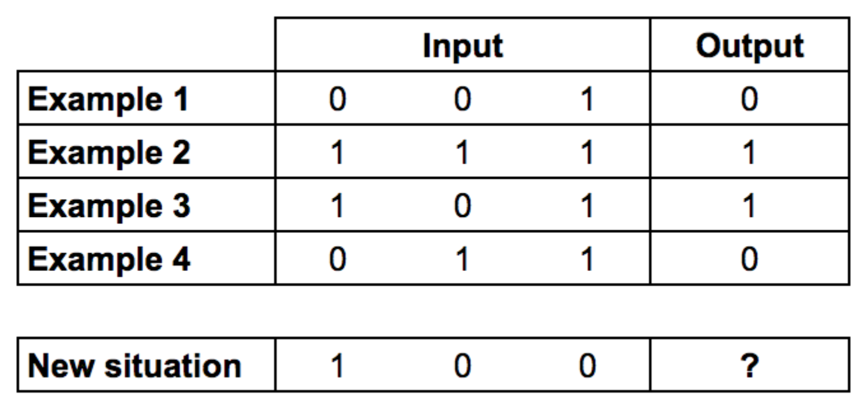

*Can you find the pattern in this table?*

*The output is always equal to the leftmost input column.*

I formulated three personal aims for my project:

1. Deepen my knowledge about how computer thinks and its overlap with brain functioning.
2. Combining aspects of Max I learned this term to something new in the form of a riddle.
3. Making Max accessible and fun to people without any knowledge in programming or music composition.

The last aim is important for me because of my personal experience. I´m new to programming and music composition. This can feel a bit overwhelming sometimes, so I think of my project as a way to ease into this field, for others and myself.

**Phase 3: Working on my patch or problems are thorny chances.**

*Friday, 26th April*

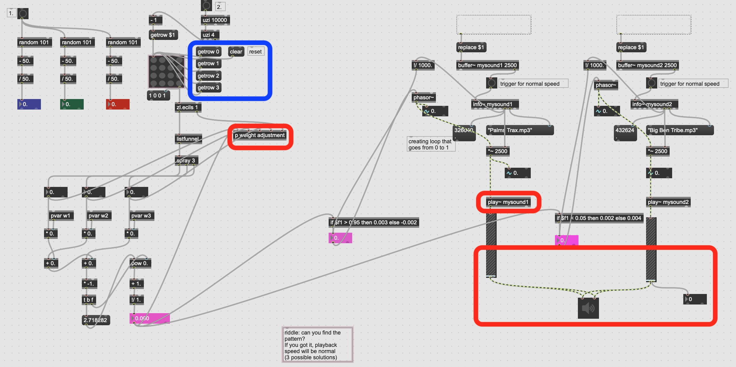

I added the “getrow” objects to the matrix because I find clicking them more convenient than always typing the numbers in a message. I extended the patch with two synchronised samples and logic arguments for the output. At the end of the day I had three main problems:

1. The weight adjustment of the input doesn´t work anymore. I tried troubleshooting, but couldn´t solve it so far.
2. The two samples always play together, but I want one playing when the output is 0 and the other when it is 1.
3. I´m starting to question if the neuron bit is an adequate choice for a riddle. The user might get confused that she or he first has to teach it the pattern. On the other hand it allows multiple solutions, so that the focus is on a learning experience based on logic and not just a random pattern.

*Thursday, 2nd May*

After some more troubleshooting I finally found the problem with the weight adjustment. For some reason it´s not working, when I´m putting it in a subpatch. So far the project taught me to always try and isolate areas of the patch to find the mistake. I also exchanged the “play” object with the “groove” object, since it´s more useful for changes in playback speed. And I decided to stick to the neuron reference, because I´m so fascinated by it and like the learning outcome. But I decided to make the riddle less complicated with the help of a clean visual design. Additionally, I deleted the second sample because I want the normal playback speed, always when the output is close to 0 and 1, meaning that the row is correct and reverse playback speed between 0 and 1, meaning the row is incorrect.

*Friday, 3rd May*

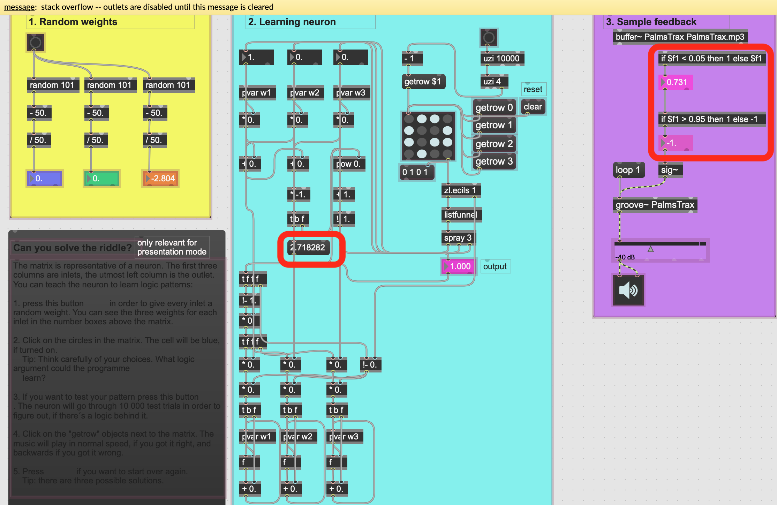

Stack overflow is killing me! I could figure out the problem for the logic arguments but not for the red circled number box. I had to redo the neuron from scratch but at least it was working afterwards. It took me a bit to figure out what logic argument would play at normal speed for the output of 0 and 1 and everything in-between backwards. I solved it with two levels of the “if” argument. I organised the patch and constructed a user surface in presentation mode.

**Phase 4: Evaluation and last fixes**

*Saturday, 4th May*

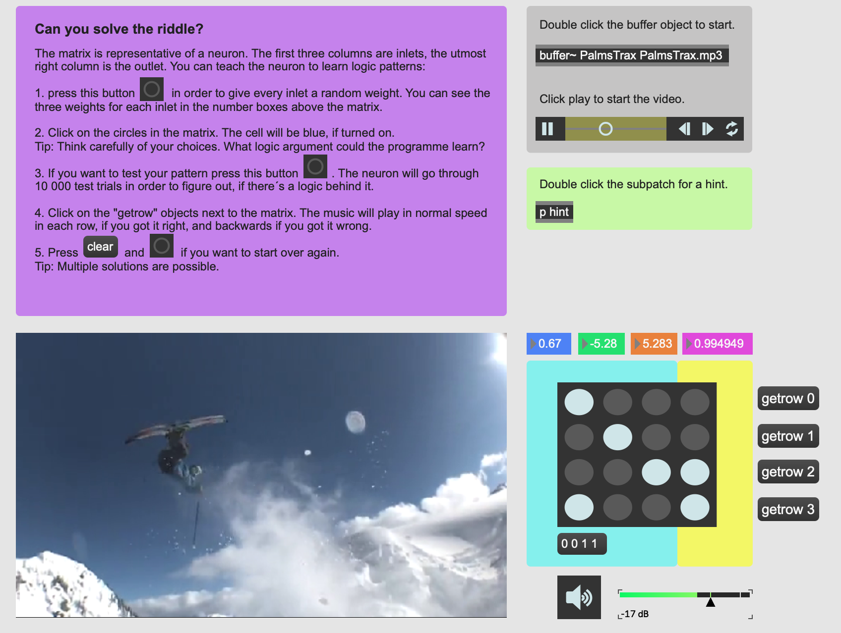

Looking at the first version of my end product, I decided to add a bit more. I thought a video might be cool, which’s playback speed serves in addition to the sample as a feedback. I made myself familiar with the “jit.movie” object using the help function since I haven´t worked with videos in Max before. It helped me figuring out how to add a reverse playback speed with the “rate -1.” message. The logic arguments to trigger the rate were a bit tricky again, but worked after some tries and errors. I searched a bit so that sound from the video would automatically be turned off when opening the patch (“@ vol 0”). I also added a subpatch with a hint, where the user can see the matrix with one right solution.

*Sunday, 5th May*

The video often freezes or doesn´t load at all. I guessed, that the video size is too big. But although I could load the video at the beginning, it just wasn´t working anymore. After a lot of troubleshooting I changed the object and work now with the “@moviefile” argument, because then it´s working for some reason.

*Monday, 6th May*

You think you finished your project and then all these tiny problems pop up out of nowhere. I needed to fix the loop of the sample and reduced the video size in the hope that the patch would work more smoothly.

*Thursday, 9th May*

In order to make the patch more user friendly, I added a message to the riddle, which says for every row whether it is “CORRECT” or “WRONG”. And I figured out, that pausing the video before the programme runs through the 10,000 test trials helps for a quicker calculation. Thus, I included this information in the instructions.